Motor Control by GSM module

Working -

Device receives the commands from the user by SMS to control the direction and speed of the motor.

Commands-

To turn on the motor - /motor on/ ,

To turn off the motor - /motor off/ ,

other commands for speed control

Schematic -

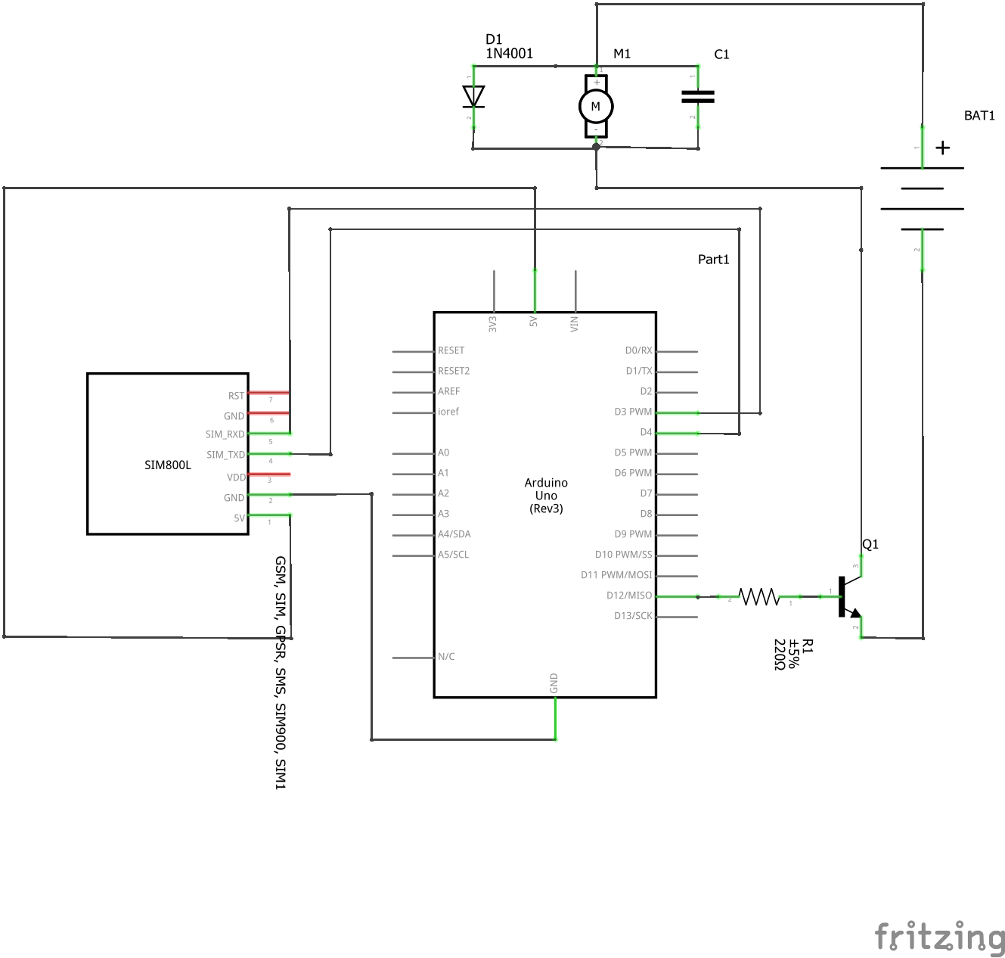

Circuit diagram-

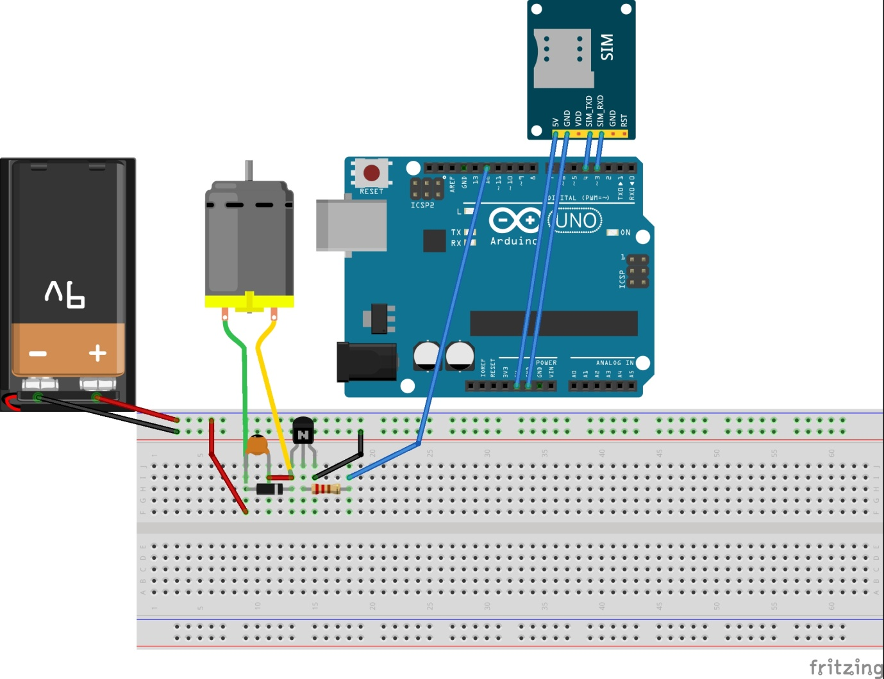

Code -